Locke, Alain LeRoy (1886-1954)

Contributors:

Bridget Chalk (Manhattan College) and

Cocoa Williams (Florida State University)

SUMMARY:

[insert fig. 1 Portrait of Locke.jpg]

Alain Locke was an American philosopher, editor and critic whose influence helped to inscribe the esthetics of this period in the history of black artistry, defining it philosophically, artistically, and politically. His guest editorship of *Survey Graphic’s* special edition on race

in March of 1925, which he titled “Harlem: Mecca of the New Negro,” and which would become in an edited and extended format his anthology *The New Negro: An Interpretation of Negro Life*, is generally considered to be the founding text of the Harlem Renaissance. Published in 1925, *The New Negro* includes contributions from what Locke called the rising generation of "Negro Youth" writers, including Langston Hughes, Claude McKay, Jessie Fauset, Jean Toomer and Countee Cullen. Locke's introduction to the volume announced a new age in African American aesthetics, one which abandoned the direct political objectives of racial uplift and dedicated itself to merging folk art with high cultural experimentation. He was born in Philadelphia, received undergraduate and graduate degrees from Harvard, and was the first African-American Rhodes Scholar. His philosophical theories focused on race relations, cultural relativism and pluralism, interests he extended to his work in promoting writers and artists now associated with the Harlem Renaissance.

MAIN ENTRY:

Alain LeRoy Locke was born Arthur Locke to parents Pliny Ishmael and Mary Hawkins Locke on September 13, 1885 in Philadelphia, Pennsylvania, where he was raised and educated. Both his parents worked as schoolteachers and as missionaries in Liberia, shaping Locke’s passions for education and service. Locke’s primary and secondary education were completed at the Charles Close School and Central High School, respectively. Before entering Harvard in 1904, from which he graduated Phi Beta Kappa, Locke attended the Philadelphia School of Pedagogy and Practice. Although Locke excelled as an undergraduate, he encountered difficulties continuing his education aboard, as several schools denied him admittance despite his Rhodes Scholar status. Eventually, Locke was accepted at Hertford College before going on to attend both Oxford and the University of Berlin. Upon Locke’s return to the United States in 1912, he began teaching in the English and philosophy departments at Howard University. In 1916, Locke returned to Harvard to complete a doctorate degree in philosophy. It was during his studies at Harvard that Locke discovered the philosophies of William James, whose ideas on universality Locke would continue to use as a counterpoint to his developing ideas on cultural pluralism and value theory. Locke returned to Howard after earning his PhD in 1918. It was during tenure at the university that he met and began his mentorship of Zora Neale Hurston and put her as well as Langston Hughes in contact with Charlotte Osgood Mason. It was also during this time that Locke embraced the Bahá'í faith. He was homosexual, though not publically so, and never married. He died in New York City in 1954.

While trained as a philosopher, Locke made his name as a critic and editor central to the development of the Harlem Renaissance. His role as editor of the seminal anthology *The New Negro* (1925) stands as his enduring achievement and earned him the moniker "Father of the Harlem Renaissance." However, he planned his unfinished *The Negro in American Culture* to be his greatest contribution to American letters (it was completed by Margaret Just Butcher in 1954 based on Locke’s notes).

[insert fig. 2 The New Negro Title Page.jpg]

The book was an expansion of a special "Harlem" issue of the magazine *Survey Graphic* that Locke had edited the previous year. It compiled essays, short stories, poetry, drama, and art by leading and emerging African American writers and artists, including Langston Hughes, Claude McKay, Jessie Fauset, Jean Toomer, Countee Cullen and others. Locke's own pioneering essays in the volume outline the new political identity of African Americans in the early twentieth century and tie this emerging agency to trends in literary expression.

In his title essay, Locke defines the current phase of Negro development and explores the evolving social psychology of American race relations. Whereas the "old" Negro was a "stock figure" of Southern prejudice and sentimentality, the New Negro inhabits a newly confident perspective on his role in American life. Locke argues that the migration to Northern cities by Southern blacks during the war should be understood not simply as an effect of economic and political conditions, but rather as motivated by a broad "new vision of opportunity, of social and economic freedom" (*The New Negro* 6). The congregation of blacks in cities, moreover, unified disparate genealogies and class positions, and Locke contends that Harlem stands as the "the laboratory of great race-welding" (7), or the ultimate example of the potential for creative empowerment made possible through this geographical shift. According to Locke, the New Negro must avoid submission to whites and angry "counter-prejudice" against them, and instead evolve from "social disillusionment to race pride" (10). A crucial route to this racial self-actualization, he argues, runs through creative expression, and a specifically a cultural resurgence in Negro art. In essays on "The Negro Spirituals" and "African Ancestral Art," Locke considers the multiple strands of the African American aesthetic inheritance, and suggests that these valuable resources can be combined with modernist strategies to achieve a "racial idiom" in Negro artistic expression.

[insert fig.3 link to lecture <http://alainlocke.com/?page_id=42>]

Writers like Hughes, McKay and Cullen "have carried the folk-gift to the altitudes of art," and thus illustrate the ways in which black "race expression" is achieving "cultural maturity" (*NN* 48).

Famously, Locke disagreed with W.E.B. Dubois's assessment of the imperatives of African American art, which Dubois saw as politically obligated to represent the race in elevating and positive ways. Locke, in the essay "Art and Propaganda" (1928), insisted that free self-expression was the only way to produce authentic art, instead of propaganda that necessarily emphasized the weaker, inferior position of the black race.

[insert fig.4 Alain_LeRoy_Locke.jpg]

Locke's philosophy belongs to the American pragmatist tradition and focuses heavily on cultural values and pluralism. His philosophical commitment to diversity informed his aesthetic criticism, as he repeatedly tied the emergence of African-American art to a new mode of racial advancement that was at once international, tied to particular traditions, and invested in the modes of high cultural experimentation that also characterized contemporary modernism.

[insert fig.5 link to archival footage https://www.youtube.com/watch?v=o8zEGCP-p6k]

Selected Works

Locke, A. (1928) 'Art or Propaganda?' *Harlem* 1(1): 12-13.

------ (ed.)(1925) *The New Negro: An Interpretation*. New York: Johnson Reprint Corporation.

*--*----(1983) *The Critical Temper of Alain Locke: A Selection of His Essays on Art and Culture*. Ed. Jeffrey Stewart. New York: Garland.

------ (1989) *The Philosophy of Alain Locke: Harlem Renaissance and Beyond*. Ed. L. Harris. Philadelphia: Temple University Press,

------ (1992) *Race Contacts and Interracial Relations*. Ed. Jeffrey Stewart. Washington, D.C.: Howard University Press

------ (2012) *The Works of Alain Locke (The Collected Black Writings Series)*. Ed. Charles Molesworth. Oxford: Oxford University Press.

Further Reading

Carter, J. (2012) 'Alain LeRoy Locke.' *The Stanford Encyclopedia of Philosophy*. <http://plato.stanford.edu/archives/sum2012/entries/alain-locke/>.

Harris, Leonard. Ed. *The Philosophy of Alain Locke: Harlem Renaissance and Beyond*.

Philadelphia: Temple UP, 1989.

Harris, L and Molesworth, C. (2010) *Alain L. Locke: The Biography of a Philosopher.* Chicago, University of Chicago Press.

# Harris, L. (ed.) (1999) *The Critical Pragmatism of Alain Locke: A Reader on Value Theory, Aesthetics, Community, Culture, Race, and Education*. Lanham, MD: Rowan and Littlefield.

Linnemann, Russell. Ed. *Alain Locke: Reflections on A Modern Renaissance Man*. Baton: Louisiana State UP, 1982. Print.

Molesworth, Charles. Ed. *The Works of Alain Locke*. New York: Oxford UP, 2012. Print.

Washington, Johnny. *A Journey into the Philosophy of Alain Locke*. New York: Greenwood P, 1994. Print.

---. *Alain Locke and Philosophy: A Quest for Cultural Pluralism*. New York: Greenwood

P, 1986. Print.

Multimedia

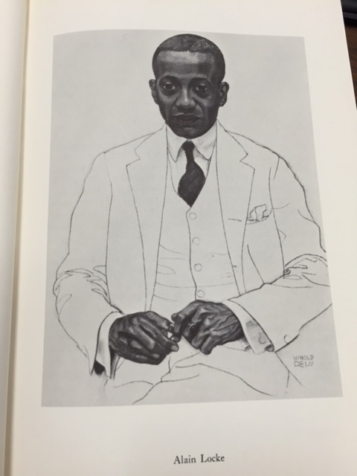

1) Portrait of Locke by Winold Reiss for

*The New Negro: An Interpretation* (1925)

Photo by Bridget Chalk

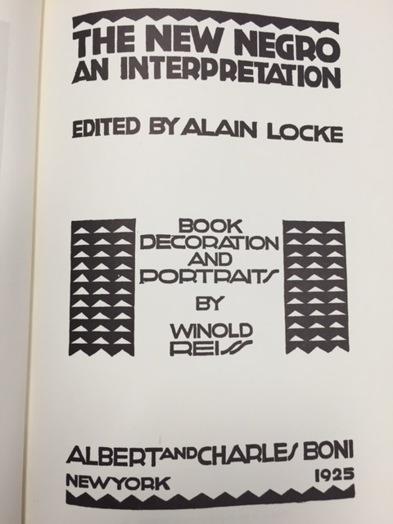

2) Title Page of *The New Negro*

Photo by Bridget Chalk

3) Link to audio clip from lecture, "The Negro Spirituals," as well as three short video clips:

<http://alainlocke.com/?page_id=42>

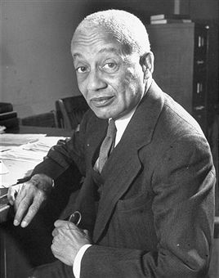

4) 1946 Photograph of Locke by Alfred Eisenstaedt.

"Alain LeRoy Locke" by Alfred Eidsenstaedt. Licensed under Fair use via Wikipedia - http://en.wikipedia.org/wiki/File:Alain_LeRoy_Locke.jpg#/media/File:Alain_LeRoy_Locke.jpg

5) Link to 1937 Footage of Locke (National Archives)

https://www.youtube.com/watch?v=o8zEGCP-p6k